Capstone Project I Instructions
Automated Client Domain System

Table of Contents
1. Prerequisites 4
2. Sending a Test DNS Request 4
Step 1 — Go to SQS → Your Queue → “Send Message” 4
Step 2 — Use a valid JSON payload 5
Step 3 — Send Message 6
3. Validating Lambda Execution 7
Step 1 — Open CloudWatch → Logs → Log groups 7
Step 2 — Open the latest log stream 7
4. Validating Route 53 DNS Record 9
Step 1 — Go to Route 53 → Hosted Zones 9
Step 2 — Search for the client 9
Step 3 — Confirm fields 10
5. Observing System Metrics (CloudWatch Metrics) 11
Step 1 — Go to CloudWatch → Metrics → Custom namespaces 11
Step 2 — Visualize or add to a custom graph 11
6. Testing Error Handling (DLQ) 13
Step 1 — Send an invalid message to SQS 13
Step 2 — Check CloudWatch logs 13
Step 3 — Go to SQS DLQ 13
Step 4 — Reprocess if needed 14
7. Viewing the Grafana Dashboard 16
8. End-to-End Validation Checklist 18
9. Grafana Panel Building (Important) 18
10. Production Deployment Notes (Internal ALB + SSM Access Required) 19
Value you need in your bitbucket repo 20

- Prerequisites
Note that some
You must have access to:
- AWS Console
- SQS queue used by the Client Domain System
- CloudWatch Logs & Metrics
- Grafana (via public ALB or SSM port forwarding, depending on environment)
- Sending a Test DNS Request

Step 1 — Go to SQS → Your Queue → “Send Message”
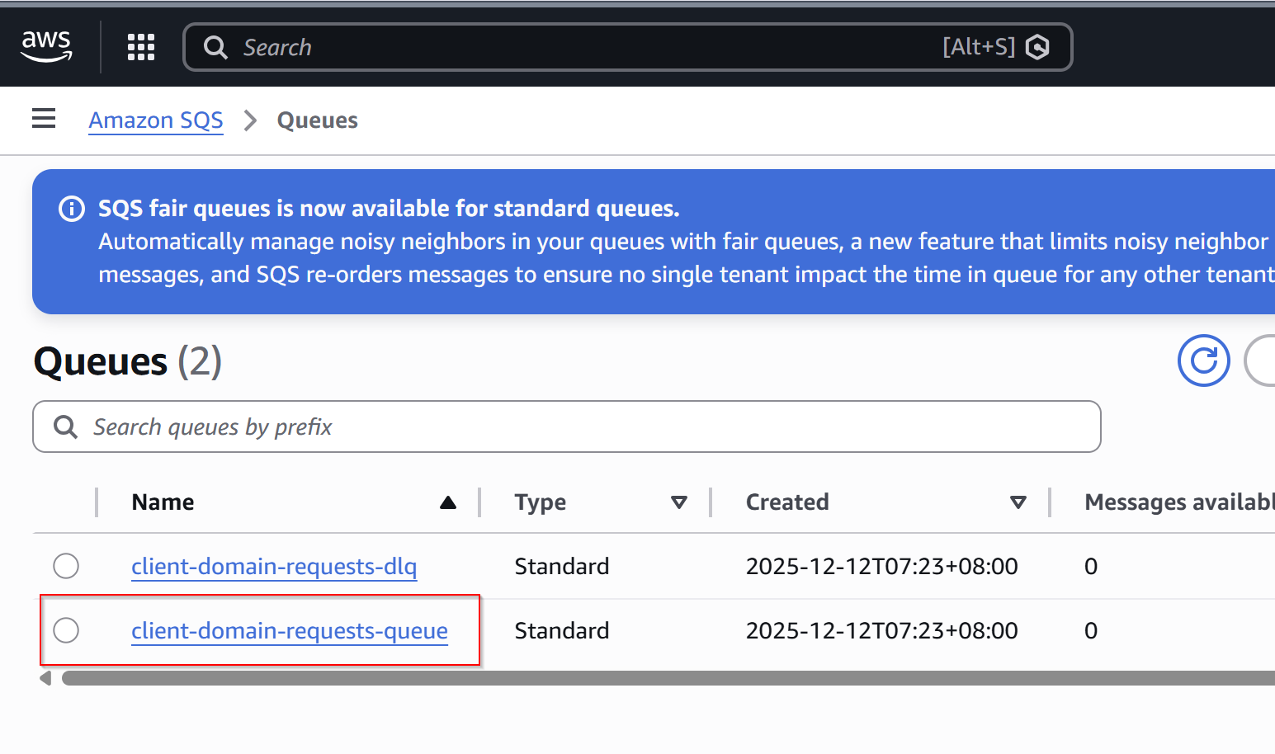
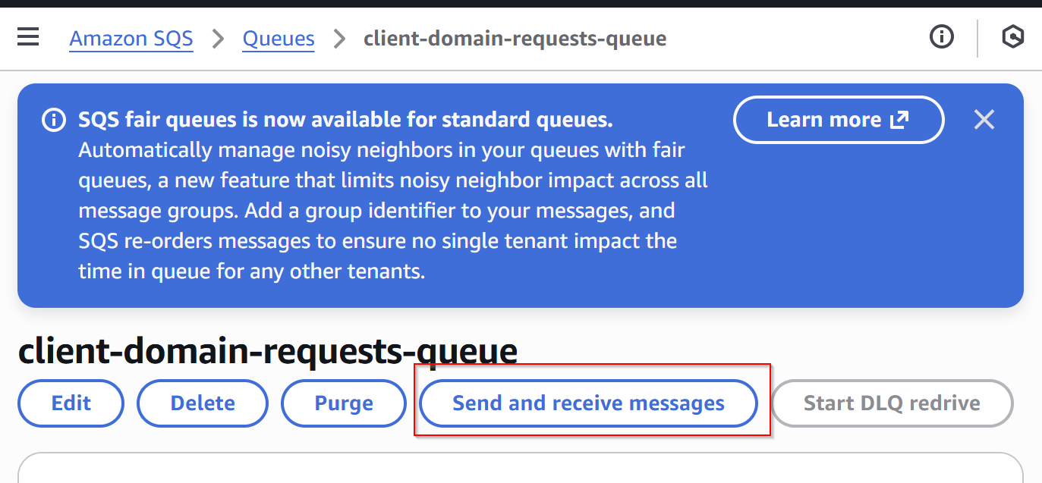

Step 2 — Use a valid JSON payload
Example (A record):
{
"action": "add",
"client": "ikea",
"source_env": "staging",
"target_env": "production",
"record_type": "A",
"target_value": "1.2.3.4"
}
Example (CNAME):
{
"action": "add",
"client": "nike",
"source_env": "staging",
"target_env": "production",
"record_type": "CNAME",
"target_value": "app.example.com"
}

Actions supported include add, update, and delete.
Note that delete operations require the provided target_value to exactly match the existing DNS record.

Step 3 — Send Message
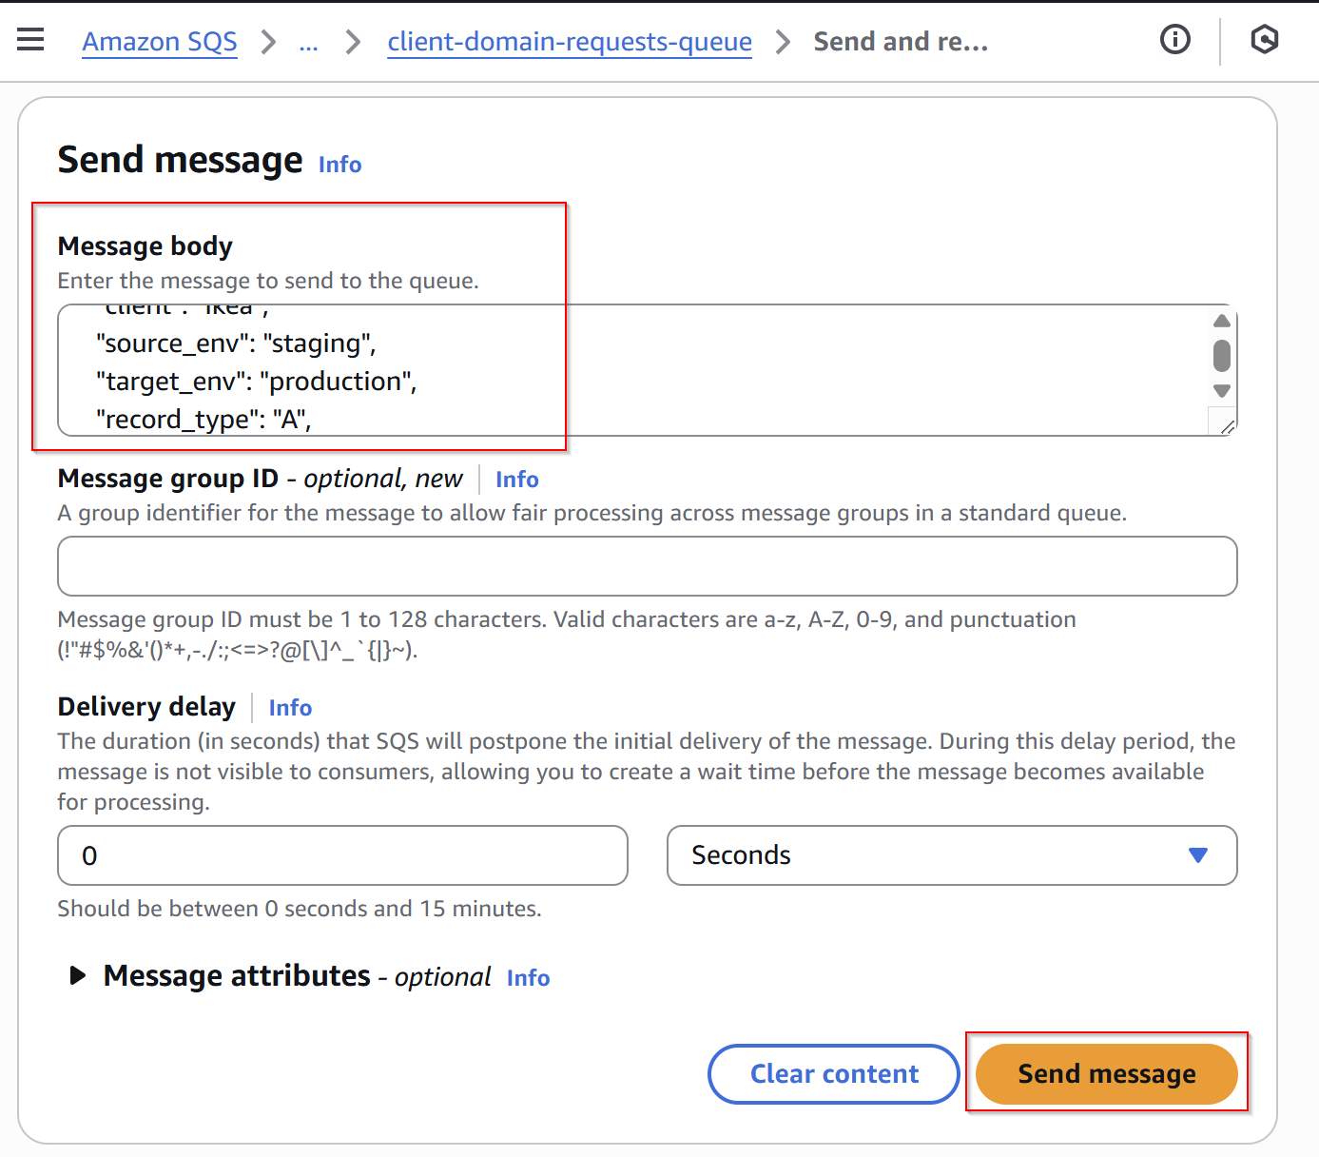
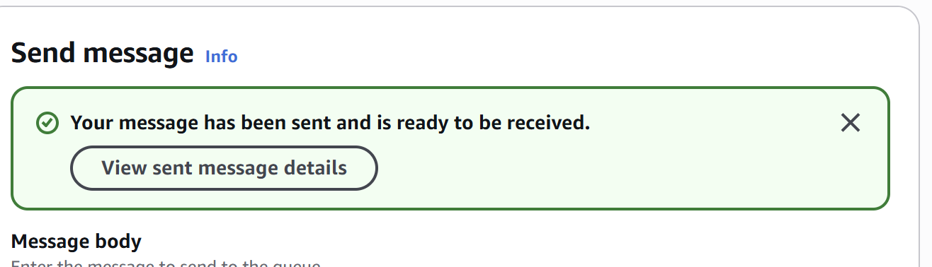
Within seconds, Lambda will process it.

- Validating Lambda Execution

Step 1 — Open CloudWatch → Logs → Log groups
Go to:
/aws/lambda/<your-lambda-name>
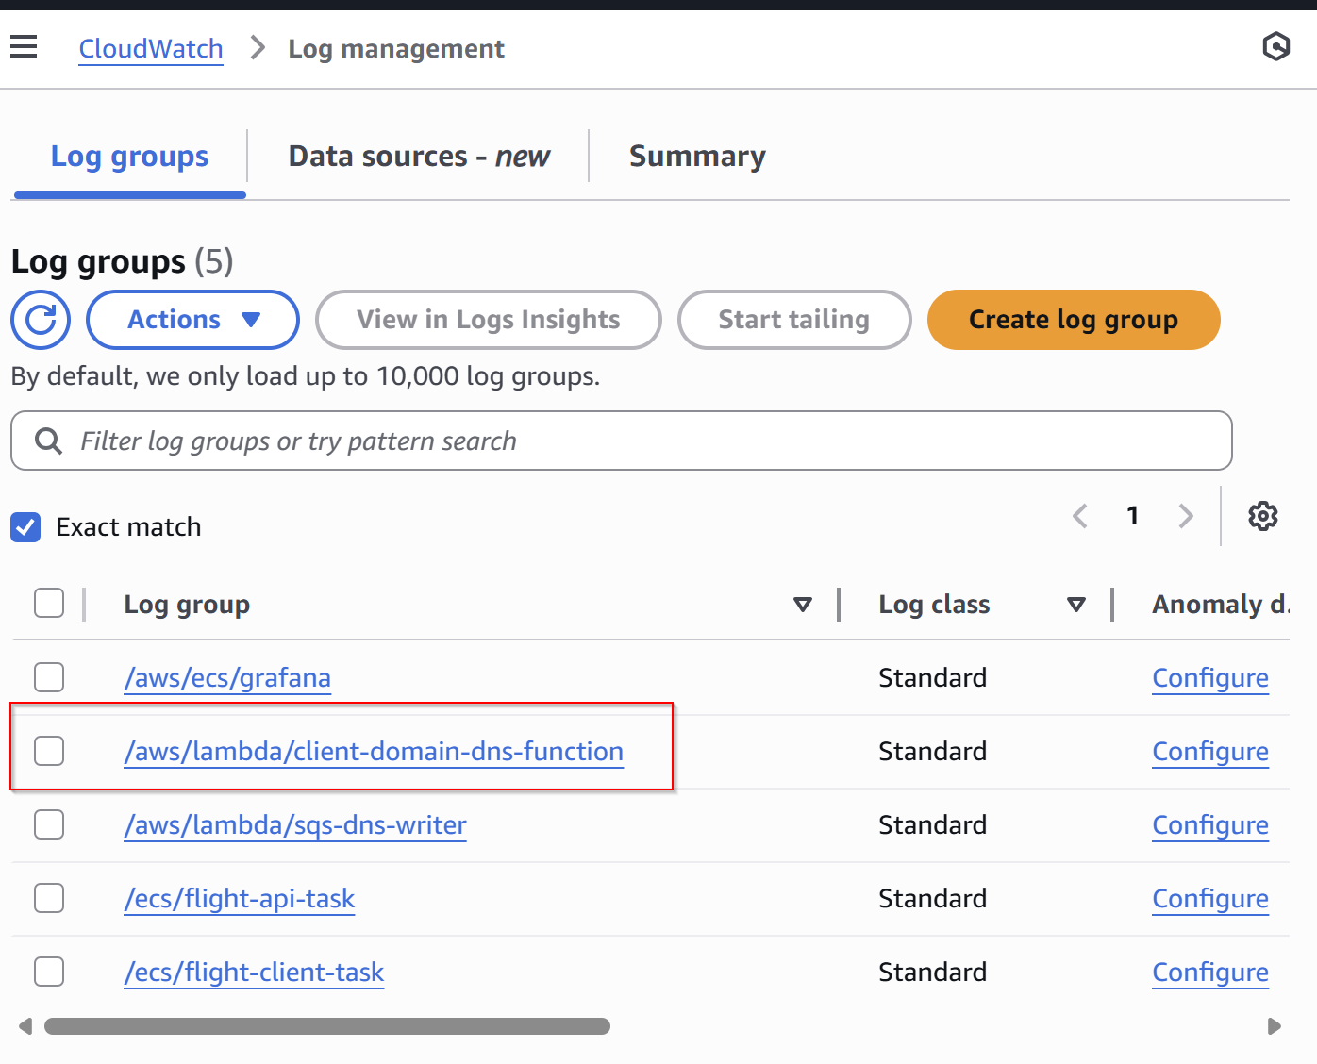

Step 2 — Open the latest log stream
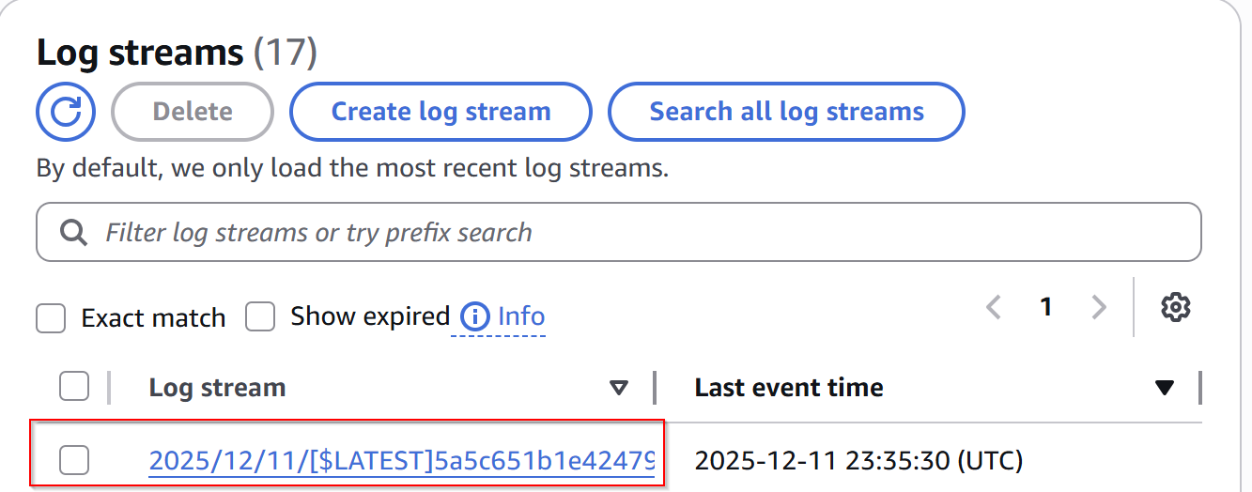
You will see structured JSON records such as:
{
"request_id": "abc-123",
"action": "add",
"client": "ikea",
"subdomain": "ikea.production.example.com",
"target_domain": "1.2.3.4",
"status": "success"
}
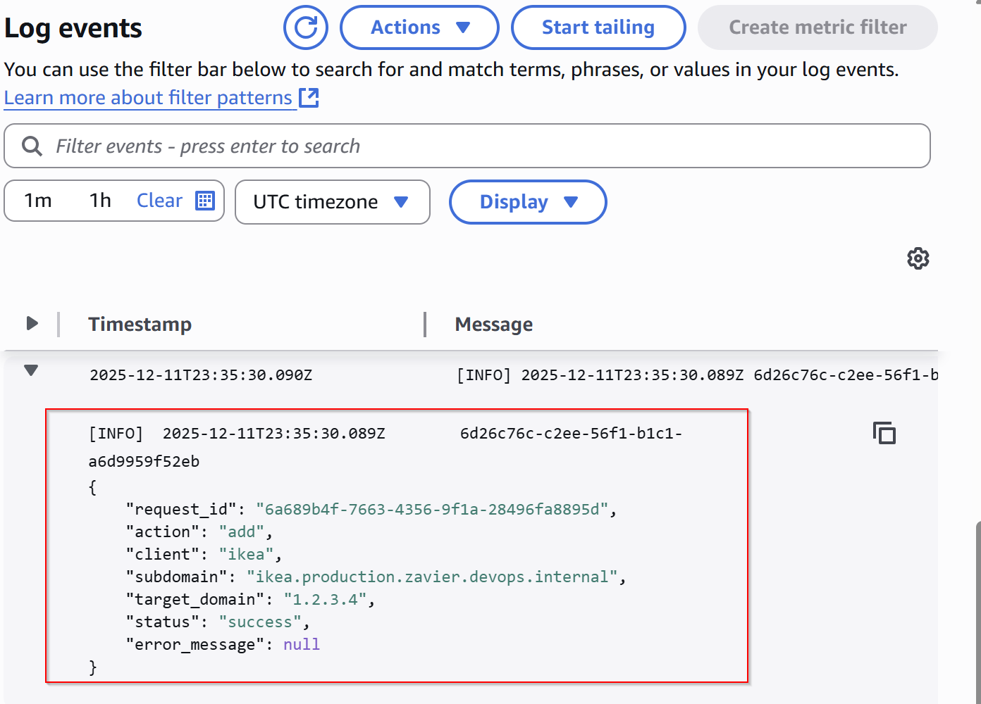
If error occurs, log will show:
{
"status": "failure",
"error_message": "Invalid record_type"
}
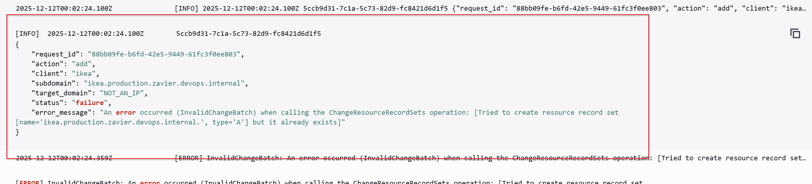

- Validating Route 53 DNS Record

Step 1 — Go to Route 53 → Hosted Zones
Open your production hosted zone.
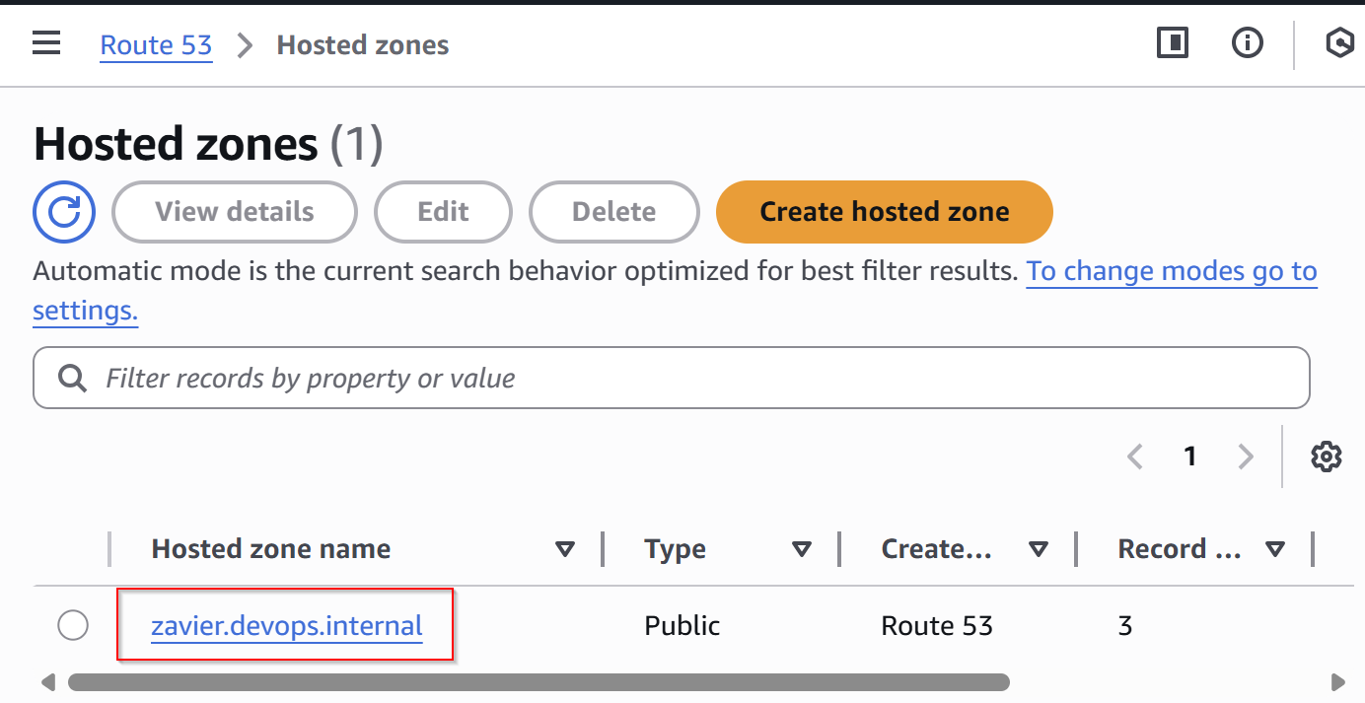

Step 2 — Search for the client
Example DNS:
ikea.production.example.com
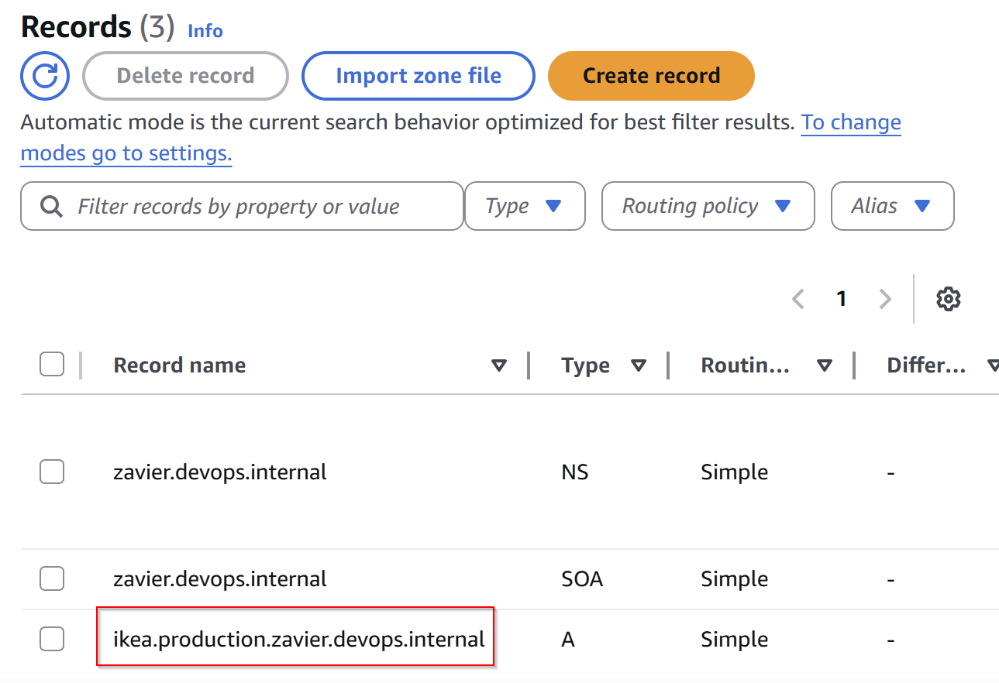

Step 3 — Confirm fields
- Record Type (A or CNAME)
- TTL (default 300)
- Value (IP or DNS)

- Observing System Metrics (CloudWatch Metrics)

Step 1 — Go to CloudWatch → Metrics → Custom namespaces
Select:
ClientDomainSystem
Available metrics include:
- SuccessCount
- FailureCount
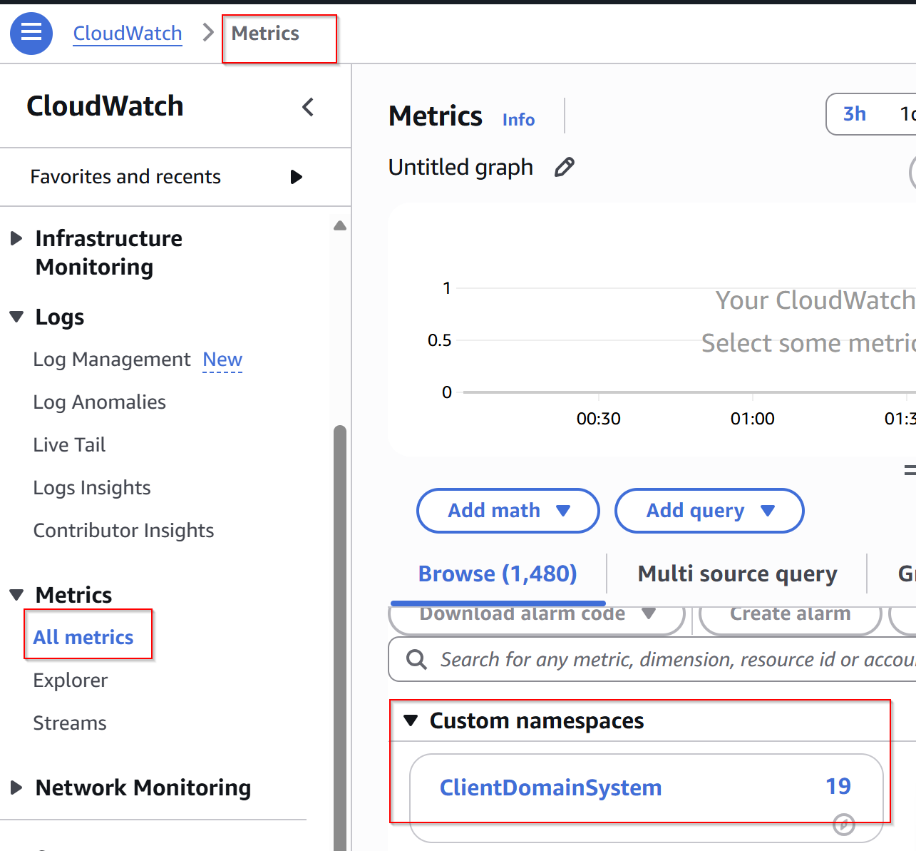
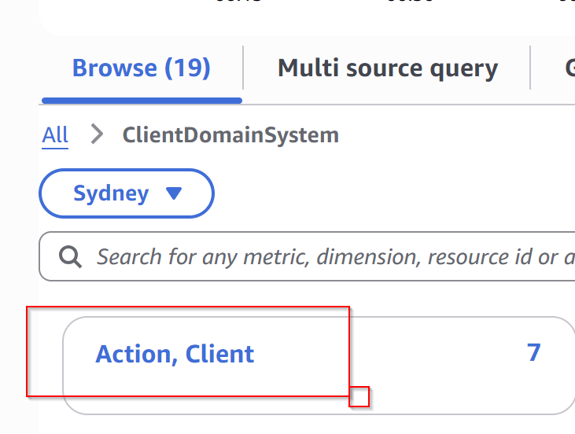
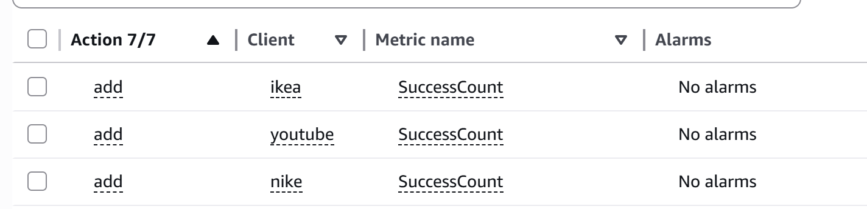
Dimensions: All metrics are now emitted with dual dimensions (Client and Action). This allows for granular filtering in the same metric view.

Step 2 — Visualize or add to a custom graph
Confirm that sending messages updates these metrics.
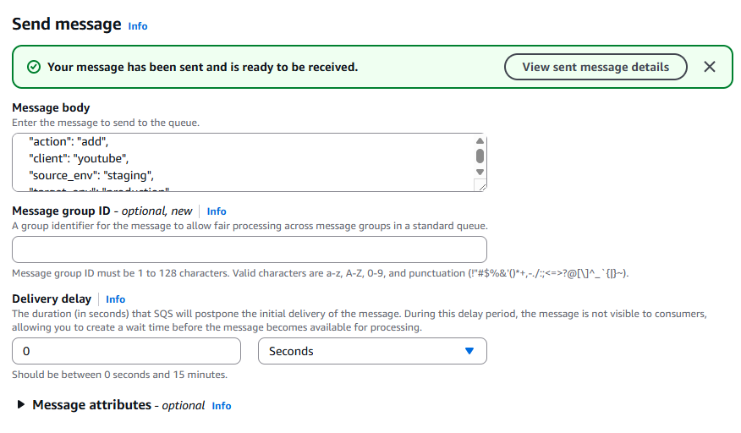
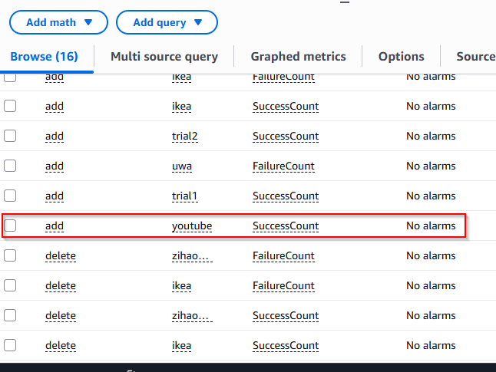

- Testing Error Handling (DLQ)

Step 1 — Send an invalid message to SQS
Example:
{
"action": "add",
"client": "ikea"
}
Missing required fields → Lambda fails.
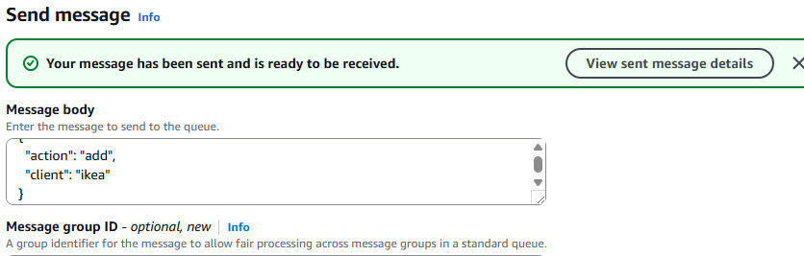

Step 2 — Check CloudWatch logs
You will see:
status: failure
error_message: Missing fields: [...]
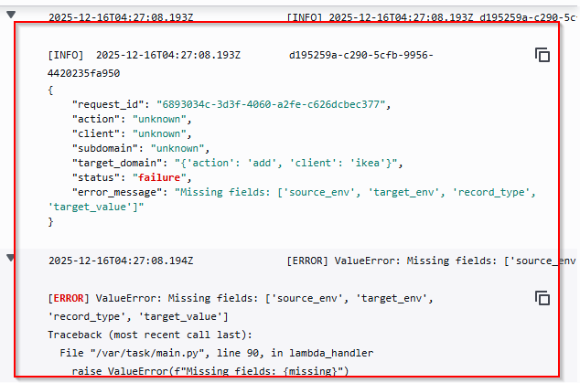

Step 3 — Go to SQS DLQ
Message will appear after retries exceed maxReceiveCount.
If it does not appear immediately, click “Poll for messages” to refresh the queue view.
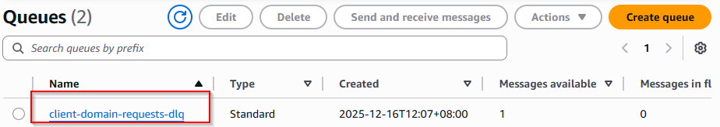
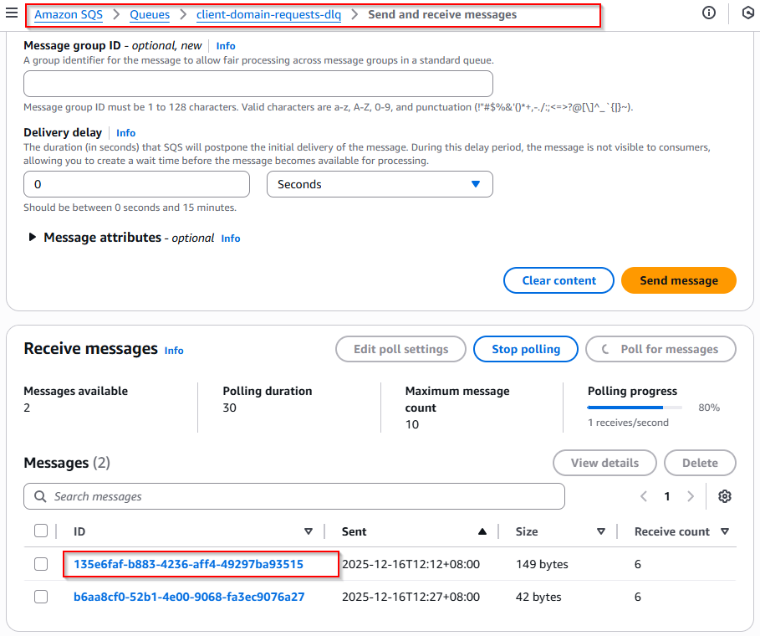
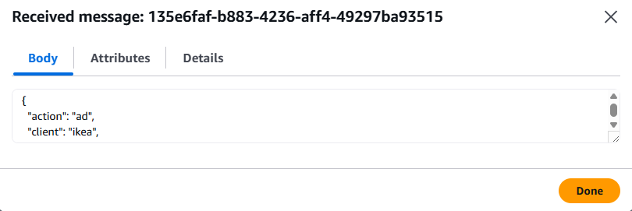

Step 4 — Reprocess if needed
AWS does not provide a direct “send back to source queue” button.
To retry processing:
- Open the DLQ message → View details
- Copy the message body
- Go to the source SQS queue
- Click Send message and paste the body
- Lambda will reprocess it immediately

- Viewing the Grafana Dashboard
Development Environment (Public ALB)
- Copy ALB DNS name
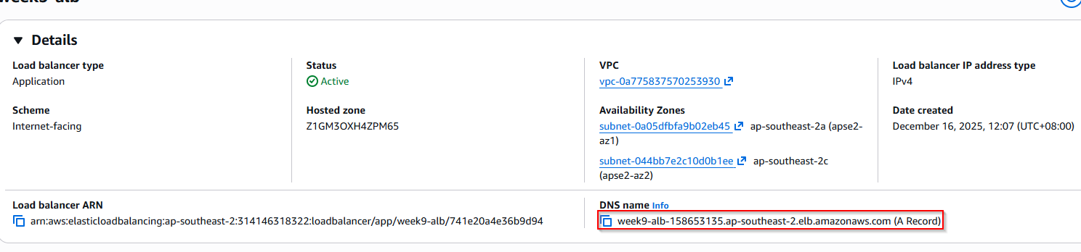
- Paste into browser
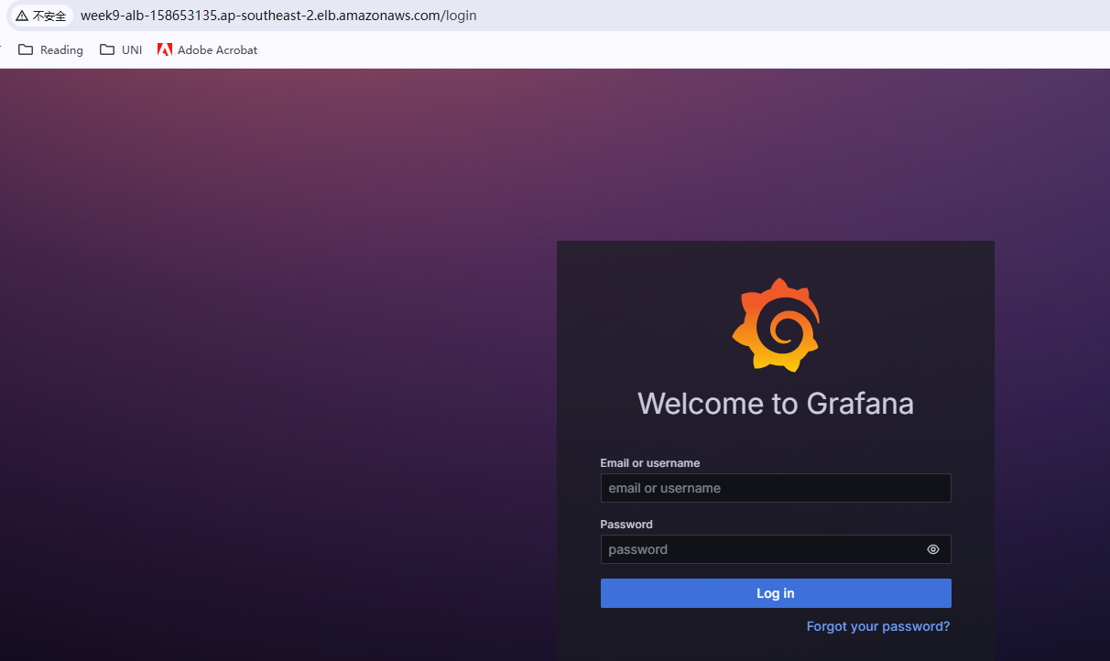
- Log in to Grafana with admin/admin, change your password, and then go to dashboards to view the data.
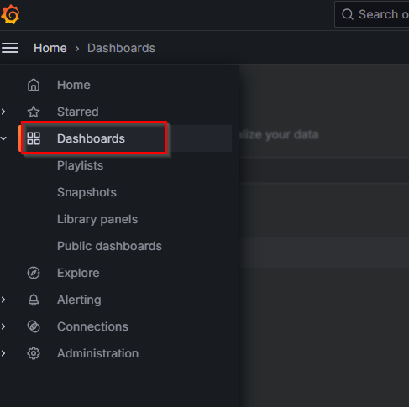
- Open the ClientDomainSystem Dashboard inside the Operation Folder.
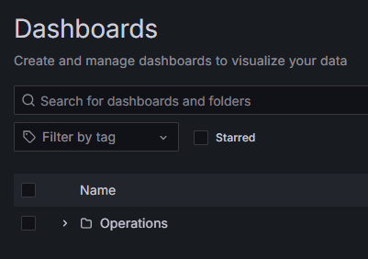
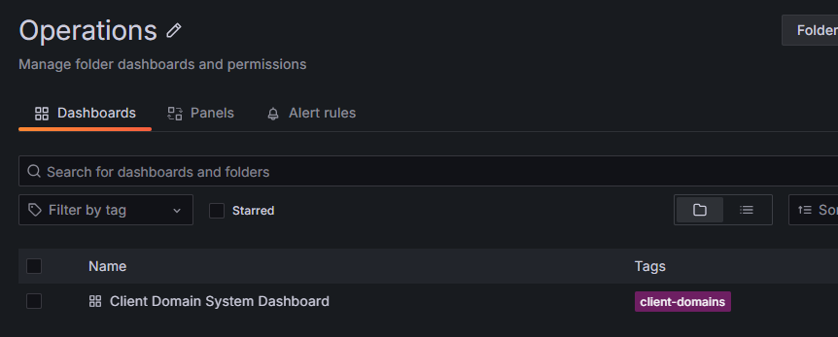
The dashboard features three main panels:
1. Lambda Invocations over time: Tracks how many times your Lambda is triggered.
2. Successful VS Failed Requests: Compares how many messages processed successfully vs. failed.
3. Recent Error logs: Shows the latest error messages so you can troubleshoot quickly.
Filter & Auto-Display: You can use the filters at the top to see data for a specific Client or Action.
- The panels update automatically based on your selection.
- Action visibility is dependent on the selected client. You must first choose a client to filter the available action list.
⚠️ Important: AWS Indexing Latency
Please be aware that AWS CloudWatch has a significant delay when registering new client names or actions in its index. While the data is processed by the Lambda immediately, the names might not appear in the Grafana dropdown menus right away. Normally, it takes less than 5 minutes, but occasionally it might require several hours for the client names to refresh during testing.
If you don't see your client in the list, don't worry, the system is working. You can verify the data is there by checking the CloudWatch Logs.

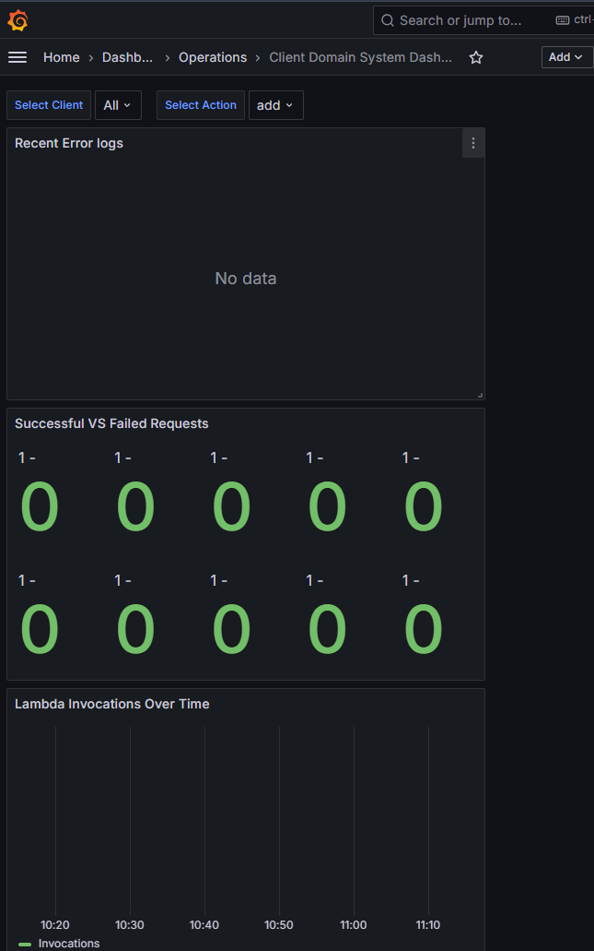

- Production Deployment Notes (Internal ALB + SSM Access Required)
The provided implementation and instructions cover development-mode deployment, where Grafana is exposed through a public ALB for convenience and demo purposes.
If this system is deployed to production, additional security hardening is required.
The ALB should be changed to internal, meaning Grafana will no longer be publicly accessible.
Engineers must then use SSM Port Forwarding to access Grafana privately inside the VPC.
Required Changes for Production
- Switch ALB to Internal
  - Set internal = true in the ALB Terraform configuration.
  - Remove any public-facing security group rules.
  - ECS tasks remain in private subnets.
- Use an SSM-Enabled EC2 as a Proxy
  - Must be in the same VPC as the internal ALB
  - Must have SSM agent enabled
  - Does not require a public IP
- Access Grafana via SSM Port Forwarding
Example:
aws ssm start-session \
--target i-0123456789abcdef0 \
--document-name AWS-StartPortForwardingSession \
--parameters "localPortNumber=3000,remotePortNumber=80"
Then open:
http://localhost:3000
- Optional Production Enhancements
  - Add CloudWatch alarms (e.g., DLQ > 0, Lambda errors)
  - Restrict IAM roles further based on least privilege
  - Remove all public access points
  - Enable VPC Endpoints for SQS / CloudWatch
Why This Is Not Implemented Here
This project deliverable focuses on demonstrating the system workflow in a development environment:
- Public access is enabled only for testing
- Terraform code is structured to allow easy conversion to production later
- The Production access workflow is documented, but not deployed
This separation ensures your demo works smoothly while still showing awareness of real-world production security practices.

Value you need in your bitbucket repo
Bucketname,key and dynamo db and your provider in main.py
DOCKER_PASS
DOCKER_USERZ
AWS _REGION
AWS_ROLE_ARN week9-alb-172369990.ap-southeast-2.elb.amazonaws.com

